电子科技大学2018-2019 学年第 一 学期期 末 考试 A 卷
考试科目： 数字逻辑设计及应用 考试形式： 闭卷 考试日期： 2019 年 01 月 09 日
成绩构成比例：平时 20% ， 期中 20% ， 小班研讨 20% ， 期末 40%
本试卷由 V 部分构成，共 06 页。考试时长： 120 分钟 注： 不准带计算器
题号 | I | II | III | IV | V | 合计
得分

得 分

I. Please fill out the correct answers in the brackets “( )” . ( 3’ × 10 = 30’)
(Please refer to the appendix for the function table of 74 chips)
1. Given the circuit shown in Fig. 1, its output F = ∏_{A,B,C} ( 0,1,4,6 ).
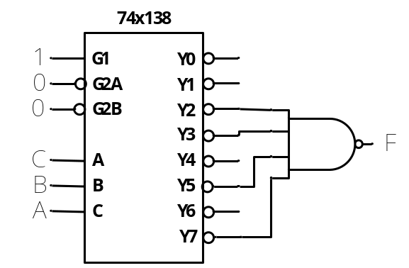
Fig. 1
2. The circuit is shown in Fig. 2, which each module is a 1-bit full adder. If the input ABC is 101, then the output F is ( 1 ).
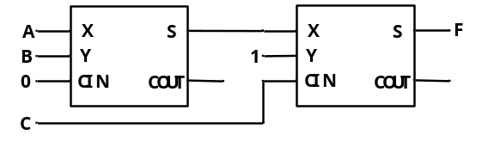
Fig. 2
3. To implement a wired AND function, ( open-drain 或 漏极开路 ) gates should be used.
4. XNOR gate in positive logic level is equivalent to ( XOR ) gate in negative logic level.
5. If the maximum voltage of an 8-bit DAC is 5V, then the output voltage is ( 0.33 )V when the input is 00010001 for the DAC. [此空答案是无限循环小数，小数位数任意]
6. Given a ROM with address input A0~A7 and data output D0~D3, its capacity is ( 1024 ) bits.
7.To realize a modulus 10 Johnson counter requires ( 2 ) 74x194 shift register(s) at least.
8. A 5-bit binary counter can have ( 32 ) normal states at most, and a 5-bit ring counter with self-correction can have ( 5 ) normal states.
9. Given the circuit shown in Fig. 3, its output F=( (AB + C) ' 或 (A'+B')C' ).
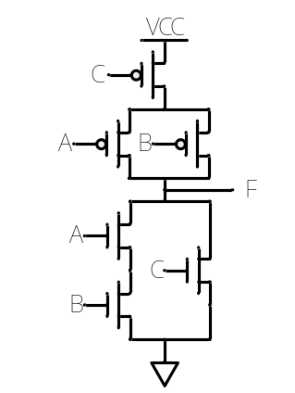
Fig. 3

得 分

II. Choose the correct answer and fill the item number in the brackets. (3’ × 5=15’ )
(Please refer to the appendix for the function table of 74 chips)
1. Consider logic family 74HCT drives 74AS, and the parameters are as following: VOHmin of 74HCT is 3.74V, VOLmax of 74HCT is 0.43V, VIHmin of 74AS is 2.1V, VILmax of 74AS is 0.8V. The HIGH-state DC noise margin is ( B )V.
A. 0.37 B. 1.64 C. 1.67 D. 2.98
2. The modulus of the counter shown in Fig. 4 is ( D ).
A. 7 B. 8 C. 9 D. 10
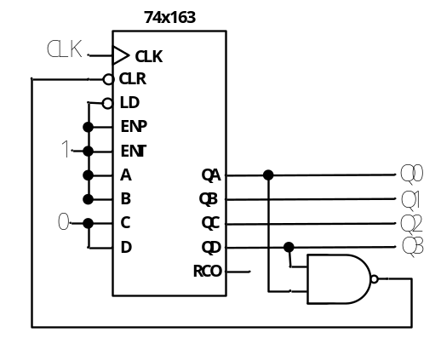
Fig. 4
3. To design a modulus 60 up/down counter by 74x163, ( C ) 74x163s are required at least.
A. 4 B. 3 C. 2 D. 1
4. Which of the following is NOT a combinational circuit? ( A )
A. 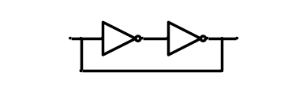 B. 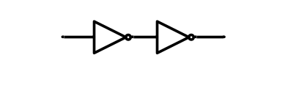

C. 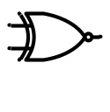 D. 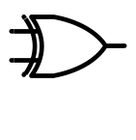
5. To build a memory with 16K×8 bits, we should need ( A ) 8K×4 memory.
A. 4 B. 6 C. 8 D. 16

得 分

III. A verilog module for 74x151 and it’s function table are shown as below. There are several errors in the module. Please find the errors and correct them. (10’)
Function Table for 74x151
En_L | Sel[2] | Sel[1] | Sel[0] | F | F_L
1 | Ø | Ø | Ø | 0 | 1
0 | 0 | 0 | 0 | Din[0] | Din[0]’
0 | 0 | 0 | 1 | Din[1] | Din[1]’
0 | 0 | 1 | 0 | Din[2] | Din[2]’
0 | 0 | 1 | 1 | Din[3] | Din[3]’
0 | 1 | 0 | 0 | Din[4] | Din[4]’
0 | 1 | 0 | 1 | Din[5] | Din[5]’
0 | 1 | 1 | 0 | Din[6] | Din[6]’
0 | 1 | 1 | 1 | Din[7] | Din[7]’

module 74x151( //1
input En_L, //2
input[2:0] Sel, //3
input[7:0] Din, //4
output F, //5
output F_L, //6
); //7
reg Out = 0; //8
assign F = Out; //9
assign F_L = Out; //10
always @ (*) //11
begin //12
if (En_L = 1) //13
Out = 1; //14
else //15
swich (Sel) //16
0: Out = Din [0]; //17
1: Out = Din [1]; //18
2: Out = Din [2]; //19
3: Out = Din [3]; //20
4: Out = Din [4]; //21
5: Out = Din [5]; //22
6: Out = Din [6]; //23
7: Out = Din [7]; //24
default: Out = 0; //25
endcase //26
end //27
endmodule //28

Please write the number of error line and the correct codes on the underlines.
You can append lines below, if you think not enough.
Line 6 is error，Modified to: output F_L
Line 10 is error，Modified to: assign F_L = ~Out;
Line 13 is error，Modified to: if (En_L = = 1)
Line 14 is error，Modified to: Out = 0;
Line 16 is error，Modified to: case (Sel)
Line is error，Modified to:
Line is error，Modified to:
Line is error，Modified to:
Line is error，Modified to:
Line is error，Modified to:
[每空正确得1分，共10分]

得 分

IV. Analyze the sequential-circuit as shown below. (15’)
1. Write out the excitation equations and output equation. [3’]
2. List out transition/output table. [4’]
3. Assume the initial state Q2Q1=00, draw the timing diagram for Q2 ,Q1 and Z. [7’]
4. Indicate the logic function of the circuit. [1’]
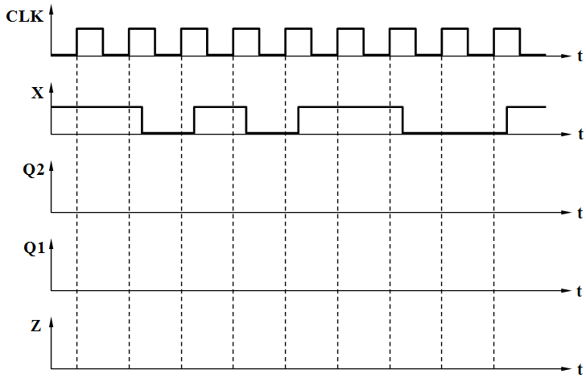
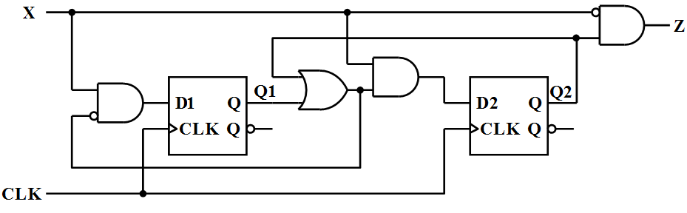
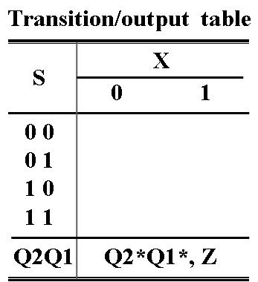

参考评分标准：
1. 激励方程: D1= X(Q2+Q1)’（1分），D2= X(Q2+Q1)（1分），输出方程Z= X’Q2（1分）
2. 转移/输出表
（每行全对得1分，局部错扣0.5分，共4分）
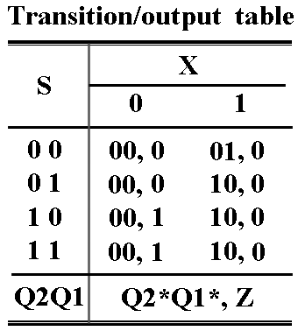

3. 定时图（Q2与Z波形各2分，Q1波形3分，共7分）
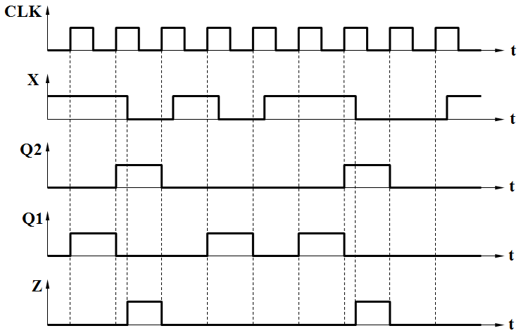

4. 功能描述：110序列检测 （正确得1分）

得 分

V. Analyze the sequential-circuit as shown below, which contains a 74x163 4-bit binary counter, a 74x138 binary decoder and a 74x151 multiplexer . (15’)
1. Write out the logic expression of LD_L . [5’]
2. Write out the state sequence in a cycle for the circuit. [8’]
3. Indicate whether the circuit is self-correctable or not. [2’]
(Please refer to the appendix for the function table of 74 chips)

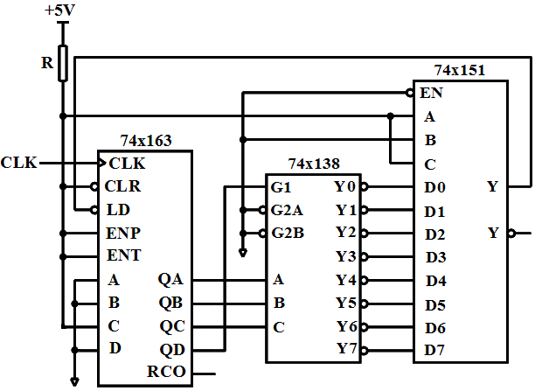

参考评分标准：
1. LD_L = (QD·QC·QB’·QA)’（正确得5分）

2. 一个循环周期的状态序列： 4, 5, 6, 7, 8, 9, 10, 11, 12, 13,
（正确得8分，错一个扣0.5分，扣完为止）

3. Yes（2分）

得 分

VI. Design a sequence signal generator with the shortest path self-correcting to generate a serial output sequence Z = 1101 using only a 74x194 and a 74x151. Please select shift left mode for the 74x194.
(15’)
1. List out the transition table and draw a full state diagram. [8’]
2. Write out the maxterm list of the feedback function LIN(QB,QC,QD). [2’]
3. Draw a schematic diagram for the circuit. [5’]
(Please refer to the appendix for the function table of 74 chips)
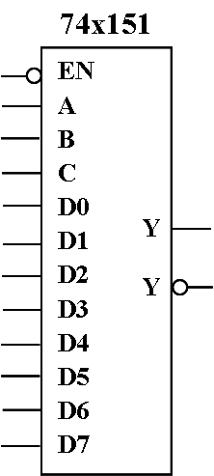
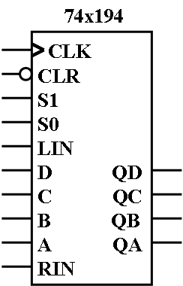

参考评分标准：
1. 转移表和全状态图
（转移表每行正确得0.5分，状态图每个转移正确得0.5分，本小题共8分）
( 转移表中如果没写 LIN列，不额外扣分； 若只是写原态和LIN，而没有写新态，考虑已内涵移位寄存器的固有特性，所以也不额外扣分)
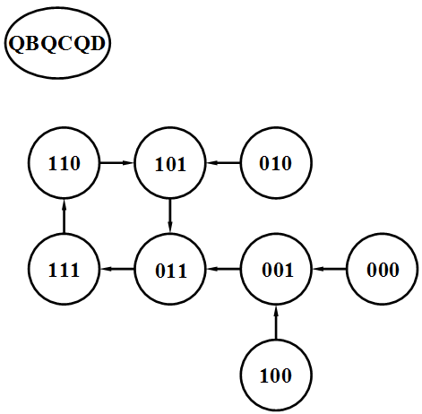
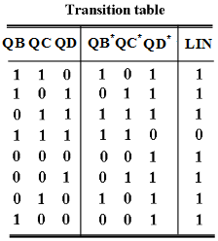

2. 反馈函数（正确得2分）
LIN = ∏_{QB,QC,QD} ( 7 ) = Q_{B}’ +Q_{c}’ +Q_{D}’， 或 LIN = ∑_{QB,QC,QD} ( 0, 1, 2, 3, 4, 5, 6 )

3. 电路图
（74x194的QB,QC,QD与74x151的C,B,A连接正确得1分，
74x151的D0~D6连接正确得1分，74x151的D7连接正确得1分，
LIN连接正确得0.5分，Z输出连接正确得0.5分，S1,S0连接正确得0.5分，CLR连接正确得0.5分，共5分）
（注：可能有些同学会用194’构建计数器实现状态转移，用151’产生相应状态下的序列位，这种情况下，必然会与题目的“only”要求不一致而使用门器件，可以因此扣2分。）

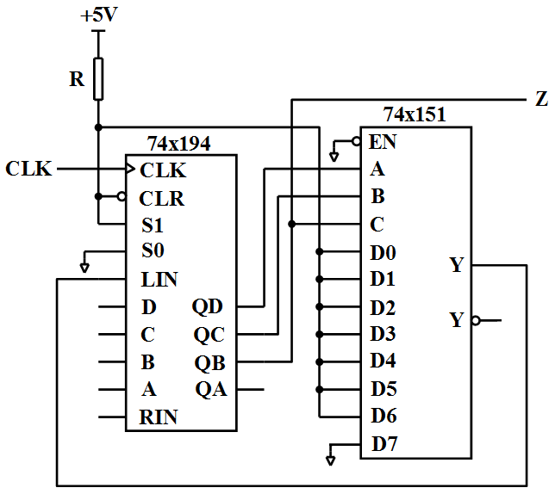
或

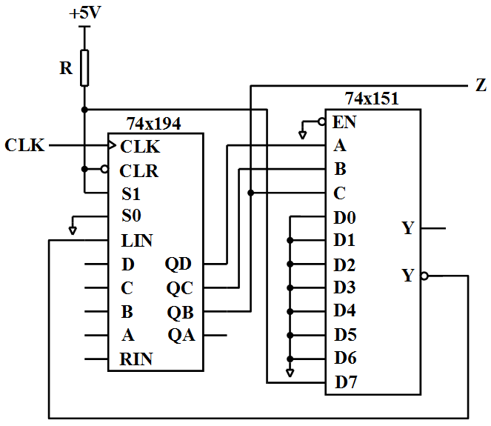
Appendix
The Truth Table for 74x138
Inputs |  |  |  |  |  | Outputs
G1 | /G2A | /G2B | C | B | A | /Y7 | /Y6 | /Y5 | /Y4 | /Y3 | /Y2 | /Y1 | /Y0
0 | X | X | X | X | X | 1 | 1 | 1 | 1 | 1 | 1 | 1 | 1
X | 1 | X | X | X | X | 1 | 1 | 1 | 1 | 1 | 1 | 1 | 1
X | X | 1 | X | X | X | 1 | 1 | 1 | 1 | 1 | 1 | 1 | 1
1 | 0 | 0 | 0 | 0 | 0 | 1 | 1 | 1 | 1 | 1 | 1 | 1 | 0
1 | 0 | 0 | 0 | 0 | 1 | 1 | 1 | 1 | 1 | 1 | 1 | 0 | 1
1 | 0 | 0 | 0 | 1 | 0 | 1 | 1 | 1 | 1 | 1 | 0 | 1 | 1
1 | 0 | 0 | 0 | 1 | 1 | 1 | 1 | 1 | 1 | 0 | 1 | 1 | 1
1 | 0 | 0 | 1 | 0 | 0 | 1 | 1 | 1 | 0 | 1 | 1 | 1 | 1
1 | 0 | 0 | 1 | 0 | 1 | 1 | 1 | 0 | 1 | 1 | 1 | 1 | 1
1 | 0 | 0 | 1 | 1 | 0 | 1 | 0 | 1 | 1 | 1 | 1 | 1 | 1
1 | 0 | 0 | 1 | 1 | 1 | 0 | 1 | 1 | 1 | 1 | 1 | 1 | 1

The function table for 74x151
Iutputs |  |  |  | Outputs
/EN | C | B | A | Y | /Y
1 | X | X | X | 0 | 1
0 | 0 | 0 | 0 | D0 | D0’
0 | 0 | 0 | 1 | D1 | D1’
0 | 0 | 1 | 0 | D2 | D2’
0 | 0 | 1 | 1 | D3 | D3’
0 | 1 | 0 | 0 | D4 | D4’
0 | 1 | 0 | 1 | D5 | D5’
0 | 1 | 1 | 0 | D6 | D6’
0 | 1 | 1 | 1 | D7 | D7’

The Function Table for 74x194
Iutputs |  |  | Next state |  |  |  | Function
/CLR | S1 | S0 | QA* | QB* | QC* | QD* | Function
0 | X | X | 0 | 0 | 0 | 0 | Asynchronous clear
1 | 0 | 0 | QA | QB | QC | QD | Hold
1 | 0 | 1 | RIN | QA | QB | QC | Shift right
1 | 1 | 0 | QB | QC | QD | LIN | Shift left
1 | 1 | 1 | A | B | C | D | Synchronous load

The Function Table for 74x163
Inputs |  |  |  | Current state | Next state | Outputs
/CLR | /LD | ENT | ENP | QD QC QB QA | QD* QC* QB* QA* | RCO
0 | X | X | X | X X X X | 0 0 0 0 | 0
1 | 0 | X | X | X X X X | D C B A | 0
1 | 1 | 0 | X | X X X X | QD QC QB QA | 0
1 | 1 | X | 0 | X X X X | QD QC QB QA | 0
1 | 1 | 1 | 1 | 0 0 0 0 | 0 0 0 1 | 0
1 | 1 | 1 | 1 | 0 0 0 1 | 0 0 1 0 | 0
1 | 1 | 1 | 1 | 0 0 1 0 | 0 0 1 1 | 0
1 | 1 | 1 | 1 | 0 0 1 1 | 0 1 0 0 | 0
1 | 1 | 1 | 1 | …………. | ………….. | 0
1 | 1 | 1 | 1 | 1 1 1 1 | 0 0 0 0 | 1

